# PLATFORM AS A SERVICE (PAAS) EXPERIMENT – 21

**AIM:**

To demonstrate Platform as a Service (PaaS) by creating and configuring a new VM image using a public cloud service provider like Microsoft Azure.

# PROCEDURE:

1. Log in to the Microsoft Azure portal using your Azure account.
2. Navigate to “App Services” from the menu and click on “Create.”
3. In the creation wizard, choose the runtime stack (e.g., Python, Java, Node.js) and select the appropriate operating system.
4. Configure the resource group, app service name, region, and select a pricing tier that supports PaaS features.
5. In the deployment settings, choose the deployment method such as GitHub or local deployment.
6. Review all the configurations and click “Create” to provision the App Service.
7. Once the App Service is deployed, navigate to the resource and access the built-in URL to verify deployment.
8. Optionally, connect a database (like Azure SQL or Cosmos DB) for backend integration under platform services.
9. Use Azure Monitor and Application Insights for performance monitoring and diagnostics.

# OUTPUT:

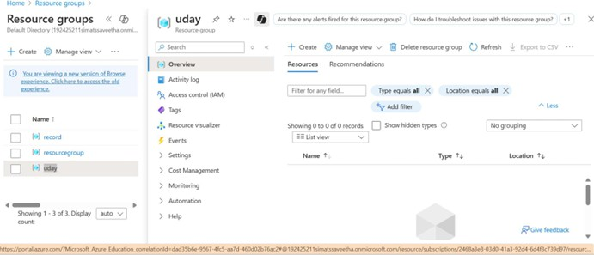

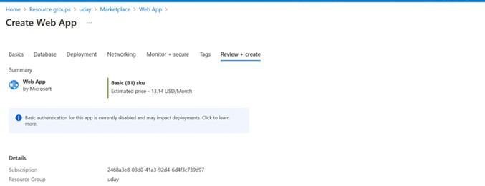

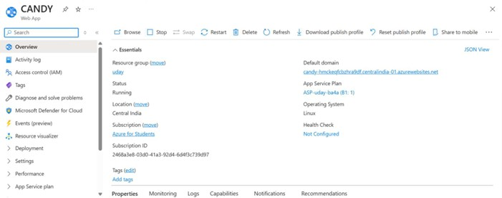

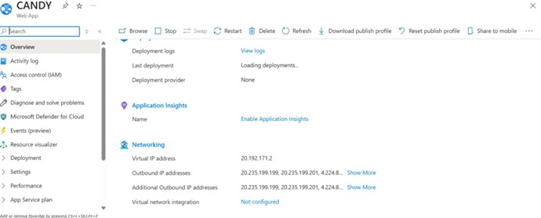

**RESULT:**

Successfully created and configured a VM-level App Service using Azure, demonstrating the concept of Platform as a Service (PaaS).